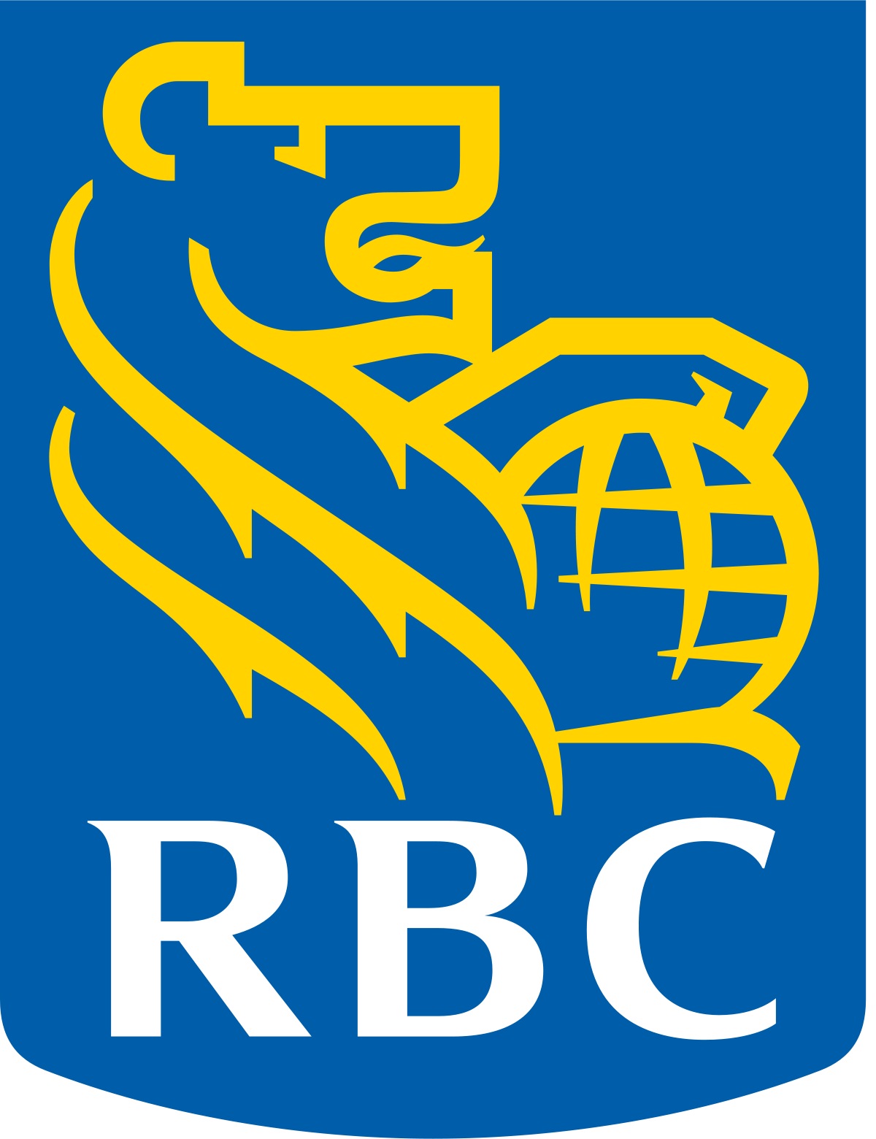

RBC Foundation Museum Mentorship

Program overview
The RBC Foundation Museum Mentorship program provides structured mentoring to emerging museum professionals developing relevant work experience and promoting future employment success. It is administered by the Canadian Museums Association (CMA) with the generous financial support of the Royal Bank of Canada Foundation’s Emerging Artists Program. Museum Mentorship funds internship two positions for emerging professionals with CMA member organizations where participants are matched with a qualified museum mentor.
With a specialized focus on mentorship for Indigenous students and graduates, participants must be ages 18 to 35, and have enrolled in programs related to museum studies, curatorship, conservation, or arts administration.

Program structure
The program provides the Indigenous emerging museum professional with a paid work experience, while also engaging in a mentoring relationship with a member of the museum’s staff.
The work experience typically focuses on one of the following disciplines:
- Exhibition Development
- Collections Management
- Programming/Education
- Conservation
- Visitor Engagement
During the mentorship component, mentors and mentees undertake discussions to help foster connections and plan for success. The curriculum of mentorship may include:
- Creating a mentoring agreement (terms of relationship, confidentiality)
- Assessing current work experience, how to get the most from it
- Undertaking self-assessment, recognizing strengths and weaknesses
- Planning a career path, including professional development
- Setting realistic expectations for the future

Program criteria
Mentoring opportunities are located in the city/region where the CMA National Conference is to be hosted, thereby ensuring that the mentee will be available to participate in the conference and gain exposure to the CMA’s vast network of professional contacts.
Proposals can be accepted from museum applicants who meet the following criteria:
- CMA Institutional membership in good standing
- Able to offer a mentorship project lasting 3 to 6 months
- Able to provide sufficient orientation, training, mentorship and support during the mentorship
- Willingness to participate in required program promotion (pre-, during and post-mentorship)
- Must use open & fair recruitment methods and select a candidate meeting the eligibility criteria
- Located in the region of the next CMA National Conference.

Frequently asked questions

How are mentorships selected?
All applications will be juried by experienced museum professionals who are committed to the advancement of young professionals. The committee’s funding recommendation may take into account:
- Level of detail in the project proposal
- Level of mentoring, orientation and supervision during the mentorship
- Project planning
- Marketability of the mentee’s skills post-mentorship
- Ability to make professional contacts during the mentorship
- Prominence of the museum
- Level of museum’s involvement in CMA and the museum community

How are mentees selected?
Mentees are recruited by the approved museum, art gallery or cultural institution that will be hosting the RBC Foundation Museum Mentorship. Mentorship opportunities will be posted on the CMA’s job board. (Please note that the CMA does not receive applications from mentees.)
Eligibility criteria for mentees are as follows:
- Must be a Canadian citizen
- Must be 18 to 35 years of age at the start of the mentorship
- Must be enrolled or a recent graduate (within past 24 months) from a museum’s studies program and/or arts studies, curatorial, conservation or an arts administrators program
- Must be willing to commit to the full duration of the mentorship
- Must be available to attend the CMA National Conference (Registration costs to be paid by CMA)
- Must not be a current or previous employee of the museum/organization
- Must be Indigenous (First Nations, Métis, Inuit, self-identified)

How much funding can be requested?

The CMA will pay up to $10,000 towards the creation of the mentorship and will cover the cost of registration at the CMA National Conference for the selected mentees.

What is the timeline for the application process?

The deadline to apply is May 15, 2020. Successful applicants will be contacted in June 2020.

Employer application form

Employer applicant
Organization:
Mailing address:
Contact person:
Contact telephone number:
Contact email:

Mentorship and work project description
Proposed job title
Project/work description
(provide specific details of the proposed work project)

Relevant skills and abilities to be gained by the participant
(include training, experience, employability skills, etc.)

Ideal candidate profile
(educational background, required skills or experience)

Name and profile of supervisor

Orientation and training
(briefly describe orientation and training for participant)

Name and position of mentor
Mentorship Plans during the project
(type and frequency of mentorship interaction, additional opportunities for mentorship within the organization or within the local community)

Post-project Mentorship Plans (how the organization will continue to support the participant’s professional development)
Benefit of mentorship for the mentee, the organization, and the community
Precautions
(lifting requirements, conditions of work environment)

Mentorship project budget
Proposed start date (YYYY/MM/DD)
Proposed end date (YYYY/MM/DD)
Length of mentorship (# weeks) (A)
Hourly wage of mentorship (B) | $
No. of hours per week (C)
Amount for employer mandatory costs (D) | $
Total mentorship salary cost [Action: (A x B x C) + D]  Result = (E) | $
Additional mentorship expenses (materials, supplies, facilities, etc.)  Result = (F) | Specify: (Type of expense) = $  Specify: (Type of expense) = $  Specify: (Type of expense) = $  Specify: (Type of expense) = $  Specify: (Type of expense) = $  Total: $
Request from RBC mentorship program (G) | $10,000
Employer project contribution [Action: E + F - G] | $
Notes of clarification to budget (if necessary):

Head of organization
NAME |  | TITLE |  | SIGNATURE |  | DATE

Position supervisor
NAME |  | TITLE |  | SIGNATURE |  | DATE

Application deadline: May 15, 2020

Please email applications to:
Sue Lamothe, slamothe@museums.ca
Subject line: RBC Mentorship

To submit by mail:
Attn: Sue Lamothe
RBC Mentorship Program
c/o Canadian Museums Association
400 – 280 Metcalfe Street
Ottawa, ON K2P 1R7

